# Inspecting a DataFrame - Shape Information

This document includes the question, the solution, and a breakdown of the code provided in the screenshot.

## Uploaded Screenshot

Below is the screenshot of the task:

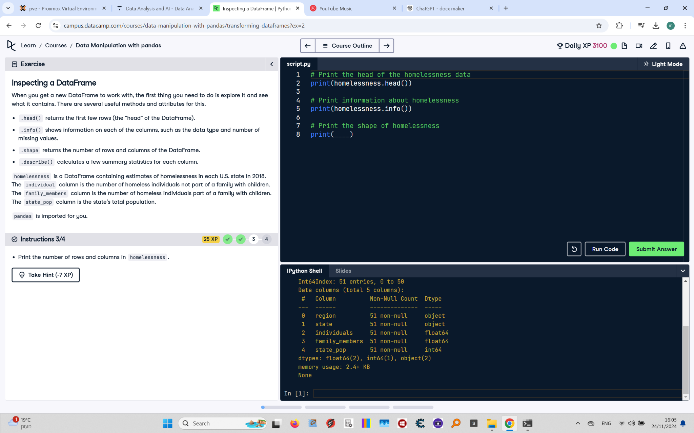

## Question

Print the number of rows and columns in the homelessness DataFrame.

## Answer

# Print the head of the homelessness data  
print(homelessness.head())  
  
# Print information about homelessness  
print(homelessness.info())  
  
# Print the shape of homelessness  
print(homelessness.shape)

## Code Explanation

# Explanation of the code:

1. `print(homelessness.head())`: This prints the first five rows of the `homelessness` DataFrame for a quick preview.

2. `print(homelessness.info())`: Provides detailed information about columns, data types, and non-null values.

3. `print(homelessness.shape)`: This prints the tuple `(number_of_rows, number_of_columns)` representing the size of the DataFrame.